

Software Design Specification Document

[Online Food Ordering System]

ICT 2212 Skills Development Project II

Bachelor of Information and Communication Technology (BICT) Degree Programme

Department of Information and Communication Technology

Faculty of Technology

Rajarata University of Sri Lanka

Mihintale

Faculty Of Technology Rajarata University Of Sri Lanaka

Details of the Project

|  |  |  |
| --- | --- | --- |
| Project Title |  | : Online Food Ordering System |
| Group Number |  | : Group Number 07 |
| Group Name |  | : OMICRON |
| Submission Date |  | : 29.05.2023 |

Group Members :

|  |  |  |  |
| --- | --- | --- | --- |
| Student Name | Registration Number | Index Number |  |
| 1. M.U.K.Gunawardhana | ITT/2017/2018/030 | 0718 |  |
| 2. K.B.Shalika | ITT/2017/2018/069 | 0754 |  |
| 3.M.G.Y.D.Gamage | ITT/2017/2018/028 | 0716 |  |
| 4. W.M.D.D.B.Wijesooriya | ITT/2017/2018/088 | 0769 |  |
| 5. S.Tharsan | ITT/2017/2018/075 | 0758 |  |

|  |  |  |
| --- | --- | --- |
| Supervisor(s) :  Name  Designation  Department  Email  Signature          Faculty Of Technology | :  :  :  :  : | Mrs. Dinusha Premasiri  Lecturer (Probationary)  Department of Information Communication and  Technology  dmpremas@tech.rjt.ac.lk  ________________ Date: _____________  i Rajarata University Of Sri Lanaka |

**Content**

1. Introduction…………………………………………………………………………………..04
2. General Overview………………………………………………………………………...04-07
   1. Role……………………………………………………………………………….…..05
   2. Responsibilities……………………………………………………………………….06
   3. System Overview…………………………………………………………………06-07
      1. Assumption………………………………………………………………………….06
      2. Constrain…………………………………………………………………………….07
      3. Dependencies………………………………………………………………………..07
3. Design Considerations…………………………………………………………………..07-08
   1. The Goals……………………………………………………………………………07
   2. Environment…………………………………………………………………………07
   3. Development methods……………………………………………………………….07
   4. Architectural style/strategies and patterns…………………………………………..08
4. System Architecture and architecture Designs………………………………………….08-10
   1. Hardware Architecture……………………………………………………………..09
   2. Software Architecture……………………………………………………………....10
5. System Design……………………………………………………………………………10-19
   1. The program design……………………………………………………………...….10
   2. Database Design……………………………………………………………………..11
   3. user interface design of the project…………………………………………………..12-19
6. Detailed Design…………………………………………………………………………..20-21

6.1. Sequence diagram 20

7. Summary 22

ii

**List of Figures**

Figure 01.network infrastructure diagram………………………………………….……………08

Figure 02. Hardware Architecture ……………………………………………………….……....09

Figure 03. Software Architecture……………………………………………………...……..…..10

Figure 04. Database Design…………………………………………………………………..….11

Figure 05. Login and Registration interfaces for distributors…………………………..……….12

Figure 06. Profile interface…………………………………………………………………..…..12

Figure 07. Order Details Interface…………………………………………...…………………..13

Figure 08. Home page 01…………………………………………………...…………..………..14

Figure 09. Home page 02……………………………………………………………...…………14

Figure10. Home page 03………………………………………………………………………....14 Figure 11. Home page 04…………………………………………………………...………..…..15

Figure 12. Login page………………………………………………………………..…………..15

Figure 13. Sign Up………………………………………………………………...……………..15

Figure 14. About Us……………………………………………………………….……………..16

Figure 15. Dishes 01……………………………………………………………………………..17

Figure 16. Dishes 02…………………………………………………………………….……….17

Figure 17. Dishes 03……………………………………………………………………………..18

Figure 18. Contact Us……………………………………………………….…………………...18

ii

Figure 19. Add to cart……………………………………………………………..……………..19

Figure 20. Sequence diagram 01………………………………………………………………...20

Figure 21. Sequence diagram 02……………………………………………………….………..21

Figure 22. Sequence diagram 03…………………………………………………….…………..21

1. **Introduction**

In the past, the food requirement was completed by people who live in the Sri Lanka using several ways but today people in competitive world find shortest path for fulfilling the food requirement with new technology. In that situation online food ordering concept is invented. This concept is very easy and save money and time of people. The online Food ordering system that we are proposing here mostly simplifies the ordering process for both the customer and the restaurant or the hotels. This System will be an interactive and up-to-date menu with all available options for all food items. There is web application and mobile application .The web application interact with user or customer and mobile application interacts with distributors(Restaurant Employees) who are delivering foods. Customer(User) can choose one or more food items to place an order which will land in the Cart. And that Cart will contain all the ordered items for delivering the order to the customer. And Customers can view all the order details in the cart before checking out. In the end, the customer gets order confirmation details. Once the order will be placed it will enter the database system and retrieved that information. This System will allow Restaurant Employees(Distributors) to rapidly go through the orders as they are received and process all orders efficiently for delivering and effectively with minimal delays and confusion to make happy the customers.

1. **General Overview**

Online Food ordering system is a process in which one can order various foods and beverages from some local restaurant and hotels using internet, just by sitting at home or any place. And the order is delivered to the told location. Nowadays everyone is having busy schedule whether it is urban area or rural. But talking specifically about the urban areas and deeply about the big cities, people out there are so busy in their life that they do not get enough of time to have their meals properly.

As these days women are no less than men, in any field. So, in big cities even wives are working women, therefore mostly the small families manage to have their food ordered from somewhere, as they lack time. Not only this is the case, if we talk about the children in the modern era, they like only fast food or something from the outside. But they ignore eating homemade meals. So food ordering system these days has one of the fastest growing market, though being a new idea. In this project we have developed something like the same to earn from and serve the nation in a much better way possible.

Nowadays, people are more regular to dine-in at restaurant for their meals. The online food ordering system provides convenience for the customers that are nothing special but the general busy people of the society. It overcomes the demerits of the manual hotel or mess system and the old fashioned queuing system. This system enhances the readymade of foods than people.

Therefore, this system enhances the speed of getting food in person’s plate and quality and manner of taking the order from the customer. It provides a better communication platform. The user’s details are stored using the electronic media. The online food ordering system provides the menu online and the customers can easily place the order by just clicking the mouse or by touching a button on their smart phones. Also with the food ordering system online, people can easily track their orders, and admin can maintain customer’s database and advance the food delivery system. This food ordering system allows the user to select the desired food items from a list of available menu items provided by the local hotel or restaurant. The user can place orders for the food items of their like from the list. The payment can be made online or pay-on-delivery system. The user’s details are maintained confidential because it maintains a separate account for each user. An id and password is provided for each user. And several encryption techniques have also been used on the server side to protect the card details. Therefore it provides a more secured and safe ordering system. In summary the existing system design include the following sub-system:

* Application - Distributed web application
* Database - SQL database
* Webserver - Apache web server (Xampp)
* Platform - Visual Studio Code/NetBeans

### 2.1. Role

* **Customer -:** The customer who are interest that online food ordering system
* **Staff -:** Employees who are performing the ordering functions of the food ordering system
* **Admin -:** Administrators who are participating ana managing employees and customers.

### 2.2. Responsibilities

We were supposed to actively participate in various web-based programming language like, PHP, HTML, Java, styling platforms like CSS and open-source libraries such as bootstrap as well as Database management systems, XAMP which provided the Apache module(server) and MySQL module. This was guidance from our project supervisor to enable us achieve the objectives of the project that was assigned to us “The Online Food Ordering System” We were tasked to make it possible for the project to solve the issue of everyone is having busy schedule whether it is urban area or rural.

### 2.3. System Overview

#### 2.4.1 Assumption

* The number of Restaurant does not change.
* The name of the dishes are not change without admin permission.
* The payment methods are not change.
* The users have sufficient knowledge of computer money and other technological knowledge.

#### 2.4.2 Constrain

* End user cannot access intermediate files without login.
* If end-user is accessing the intermediate file without login, then he/she can access the secured information without any authority. Hence security constraint provides authentication.
* An operating system supporting all the hardware and software is available.

#### 2.4.3 Dependencies

Although basic password authentication and role-based security mechanisms will be used to protect Faculty Result Management System (OFOS) from unauthorized access. Functionality such as inserting, deleting, and updating are assumed to be sufficiently protected under the existing security policies applied by the FRMS developing team. It describes dependencies regarding the software and its use.

These may concern such issues as:

**Related software:**

* Xamp Server
* Laravel ,Java script,HTML,CSS
* Apache server and SQL server
* Related Hardware:
* Micrprocessor:
* RAM:
* Hard Disk:
* OS: We use windows 11 64bit Operating System for developing this system.

**3. Design Considerations**

### 3.1. The Goals

The primary goal of the project is to create an efficient, user-friendly, and secure food ordering system that allows delivery persons to view the order details and deliver food to customers. The following guidelines is followed to achieve this goal:

* The system can handle multiple users simultaneously.
* With clear instructions and prompts, the system can be easy to use and navigate.
* The system has a secure login and registration process to protect user information.
* The system has a responsive design that is accessible on multiple devices and screen sizes.
* The system allows delivery persons to view their assigned orders and track the delivery status in real-time.

### 3.2. Environment

The following environment is used for the development and deployment of the system:

* The web application is developed using Laravel, MySQL, and Apache.
* The mobile application is developed using Java and Android Studio.
* The system is hosted on a reliable and scalable cloud hosting platform Oracle Cloud.

### 3.3. Development methods

The following development methods are followed during the development of the system: • Agile development methodology is followed to ensure that the system is developed in an iterative and incremental manner.

* Test-driven development (TDD) is used to ensure that the system is thoroughly tested before deployment.
* Continuous integration and continuous deployment (CI/CD) are used to ensure that the system is deployed quickly and reliably.

### 3.4. Architectural style/strategies and pattern

The following architectural style/strategies and patterns are used during the development of the system:

* The system uses client-server architecture with the Laravel backend as the server and the Laravel frontend as the client.
* The system uses RESTful API to communicate between the client and the server.
* The system uses Laravel, a PHP-based web framework, based on the Model-ViewController (MVC) architecture.
* The system uses a real-time database such as MySQL to enable delivery persons to track the delivery status of their assigned orders in real-time.
* The system uses API-key based authentication to ensure that only authorized delivery persons can access the order details.

**4. System Architecture and architecture Designs**

Architecture design is the process of creating a detailed plan or blueprint for the overall structure and organization of Food Ordering System including hardware, software, network infrastructure diagrams . It involves defining the components, interfaces, and interactions between different subsystems(Delivery section,Ordering pert,Admin responsibility)and components, as well as specifying the technical requirements and constraints of the system.

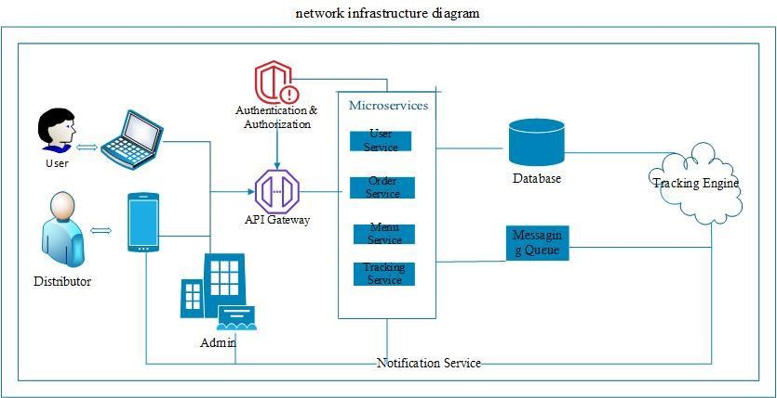

4.network infrastructure diagram

### 4.1. Hardware Architecture

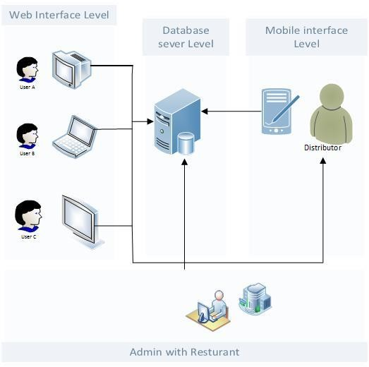

4.1.Hardware Architecture

### 4.2. Software Architecture

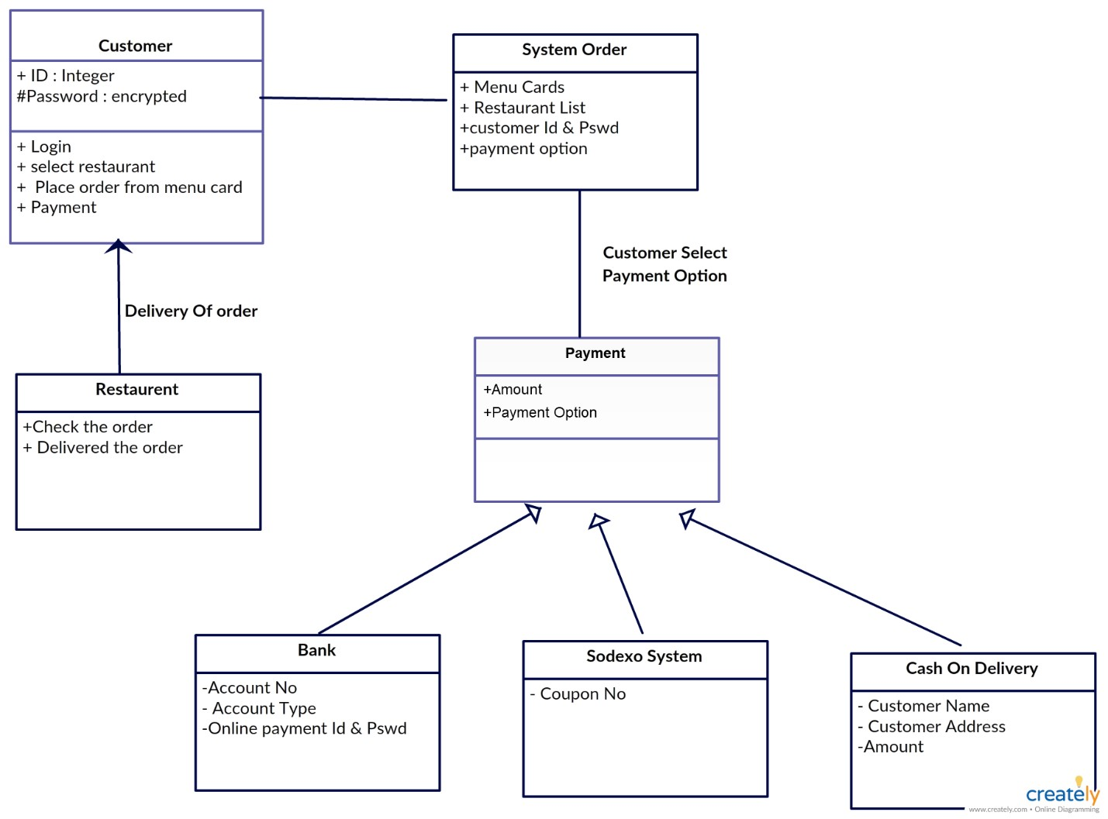

4.2. Software Architecture

**5. System Design**

### 5.1. The program design

**User Interface:** This component is responsible for providing an interface for customers to place orders. It could be a web application that allows users to view menu items, customize their orders.In mobile application,Distributor (Person who delivery orders to customer) can view customer’s contact details.Admin can view both two applications.

**Menu Management:** This component is responsible for managing the menu items that are available for customers to order. It includes the ability to add, edit, and delete items from the menu.

**Order Management:** This component is responsible for managing orders that are placed by customers. It includes the ability to track the status of orders, update order details, and generate ed information which sent distributors.

**Delivery Management:** This component is responsible for managing the delivery of orders to customers. It includes the ability to track the status of deliveries and assign delivery personnel to orders.

**Database Management:** This component is responsible for managing the data that is stored in the system. It includes the ability to store and retrieve data related to users, menu items, orders, and deliveries.

### 5.2. Database Design

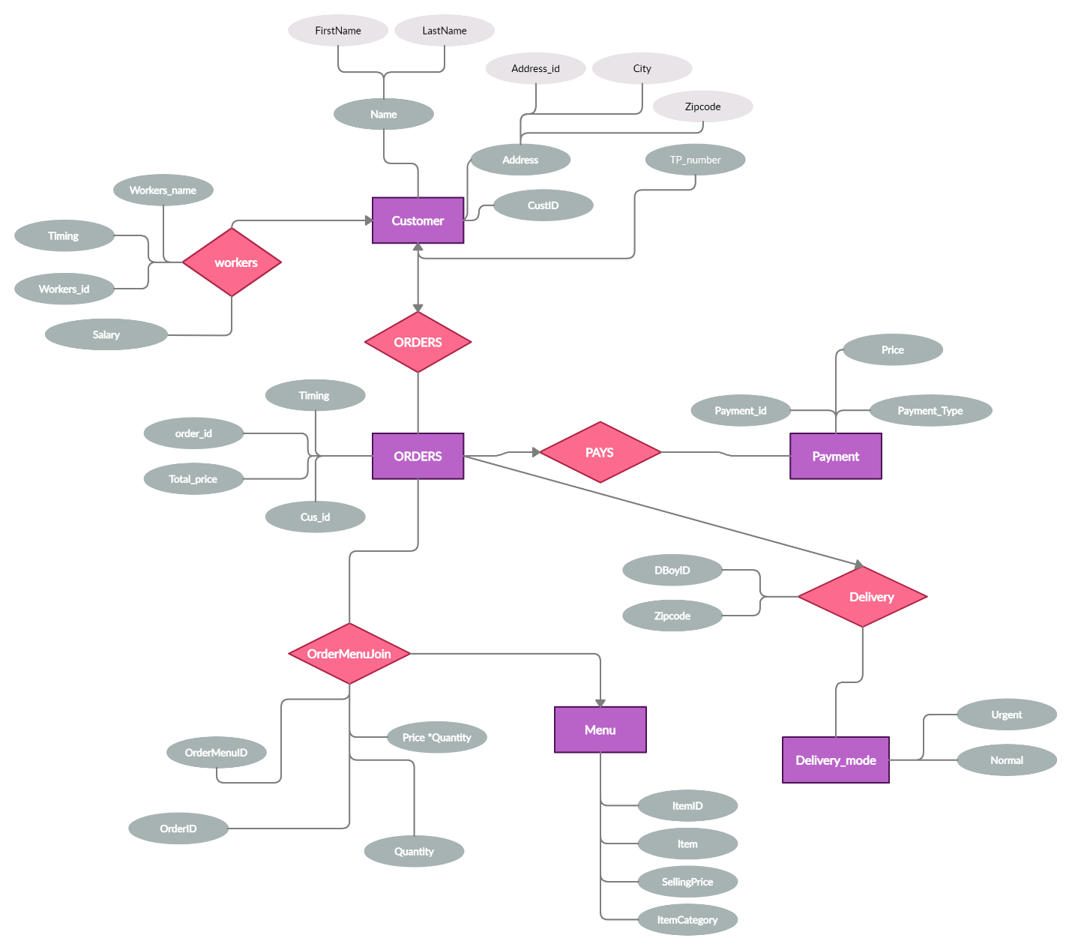

5.2.

Database Design

### 5.3. user interface design of the project

#### • mobile application Login and Registration interfaces for distributors

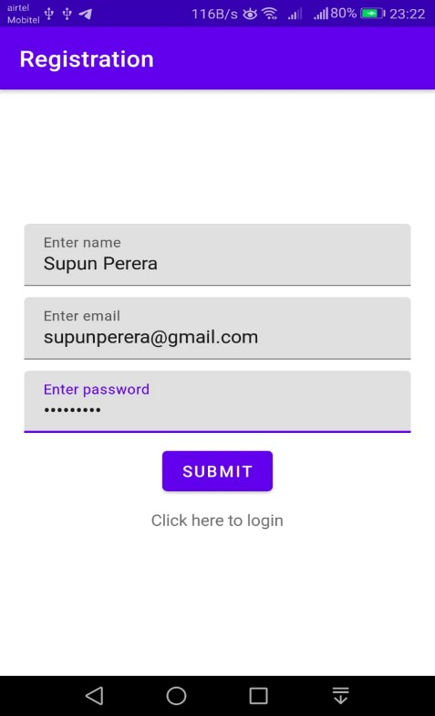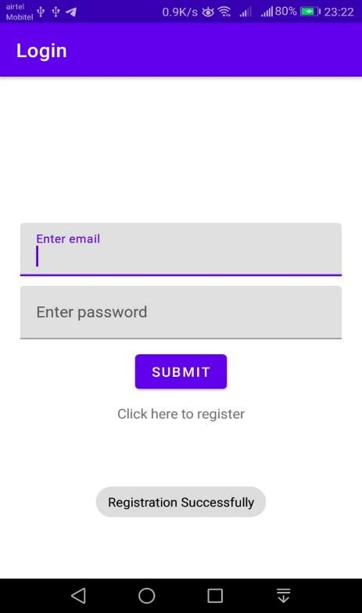

5.3.1 Login and Registration interfaces for distributors

#### Profile interface

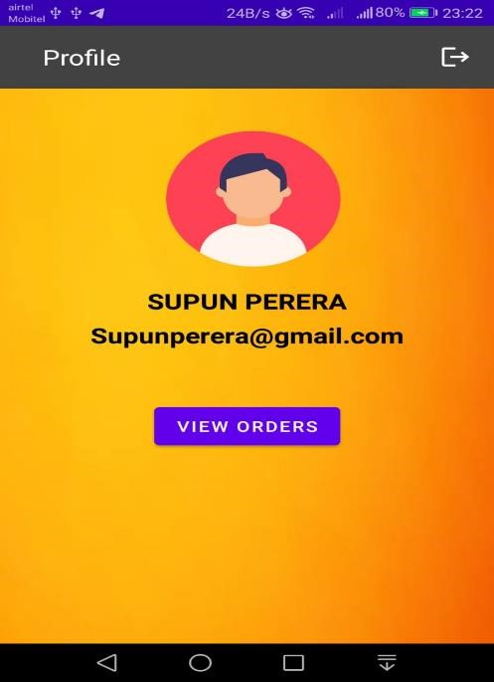

5.3.2 Profile interface

#### Order Details Interface

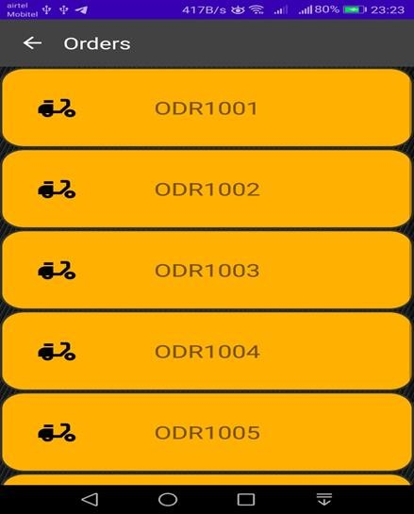

5.3.2 Order Details Interface

• **Web application**

#### Home Page

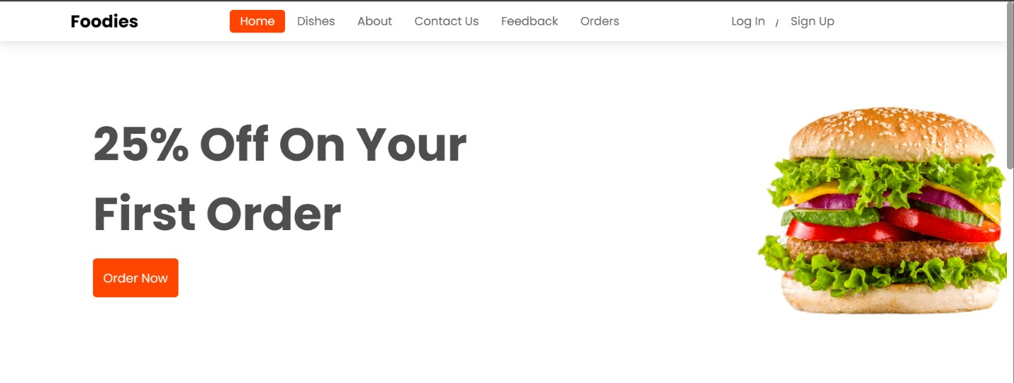

##### 5.3.3 Home page 01

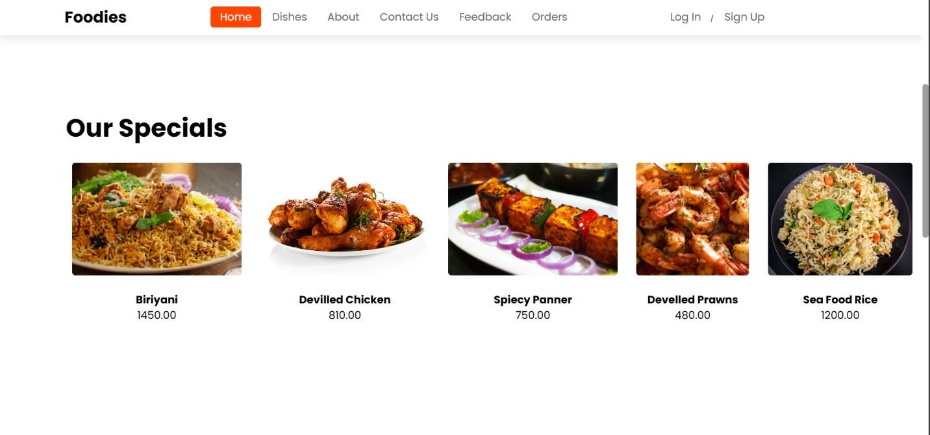

5.3.

5

Home page 0

2

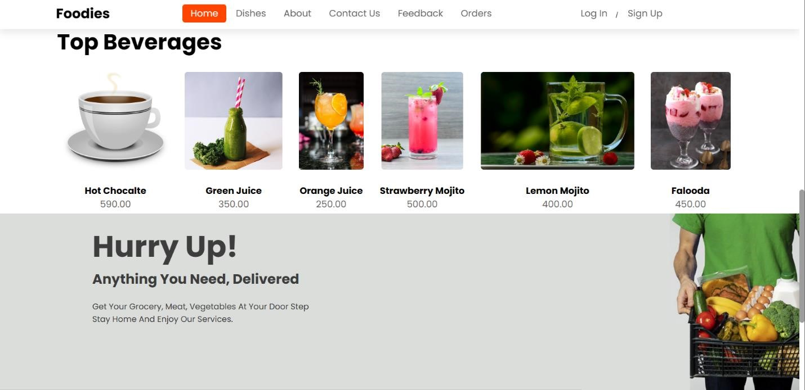

##### 5.3.6 Home page 03

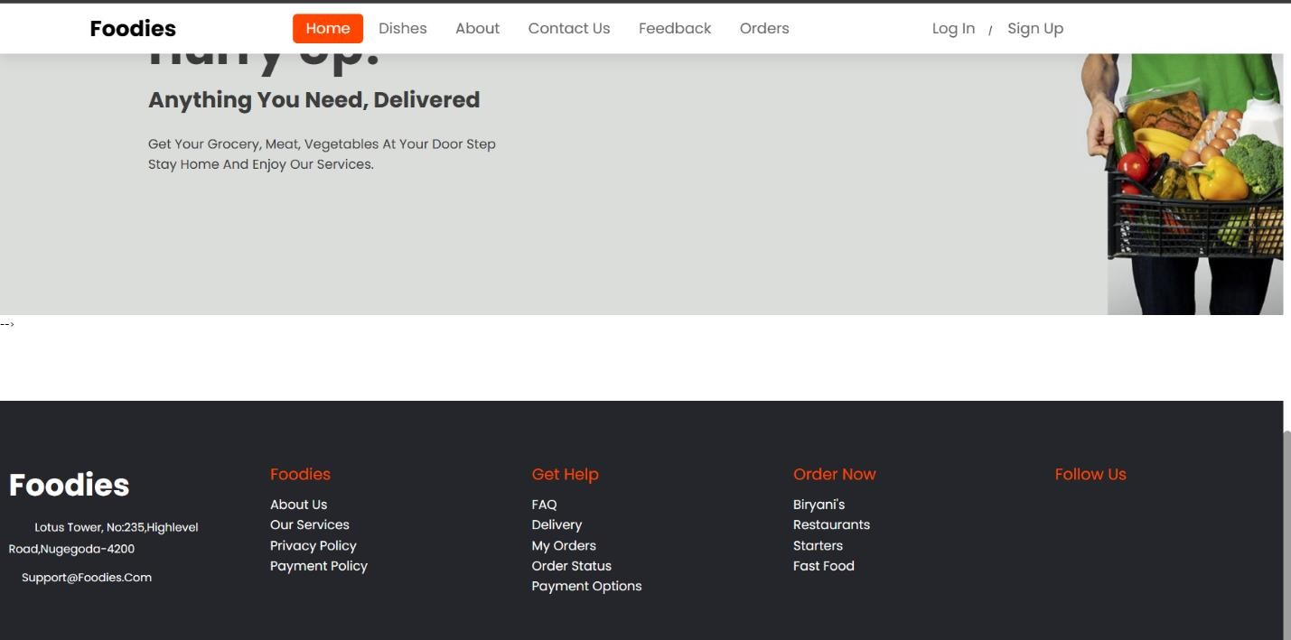

5.3.7 Home page 04

#### Login For user and admin

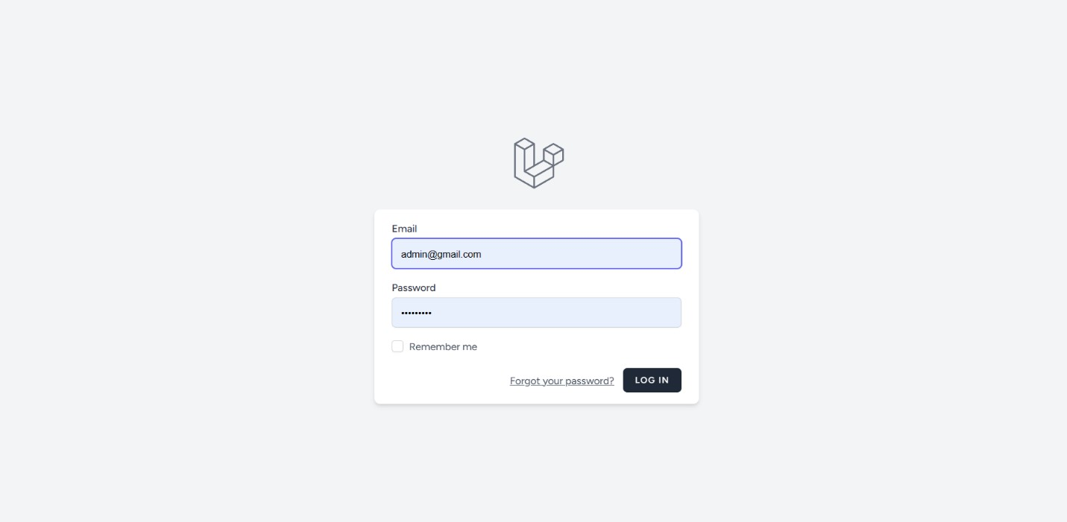

5.3.8 Login page

#### Sign Up for user and admin

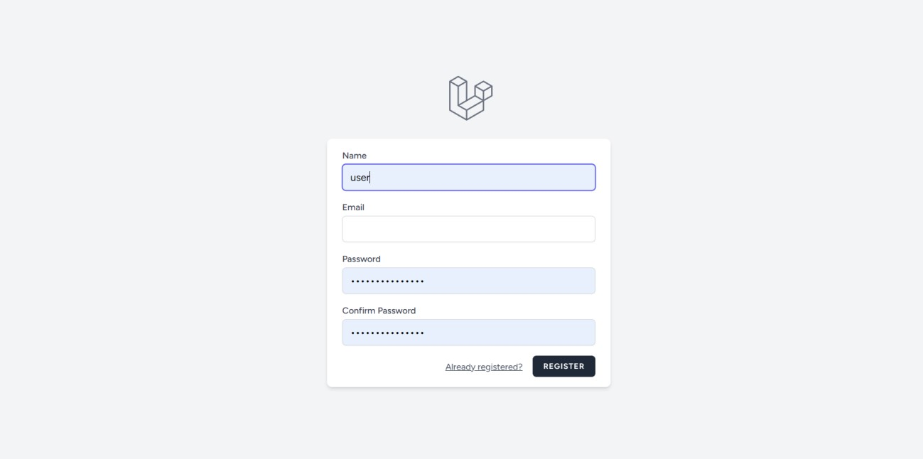

5.3.9 Sign Up

#### About Us

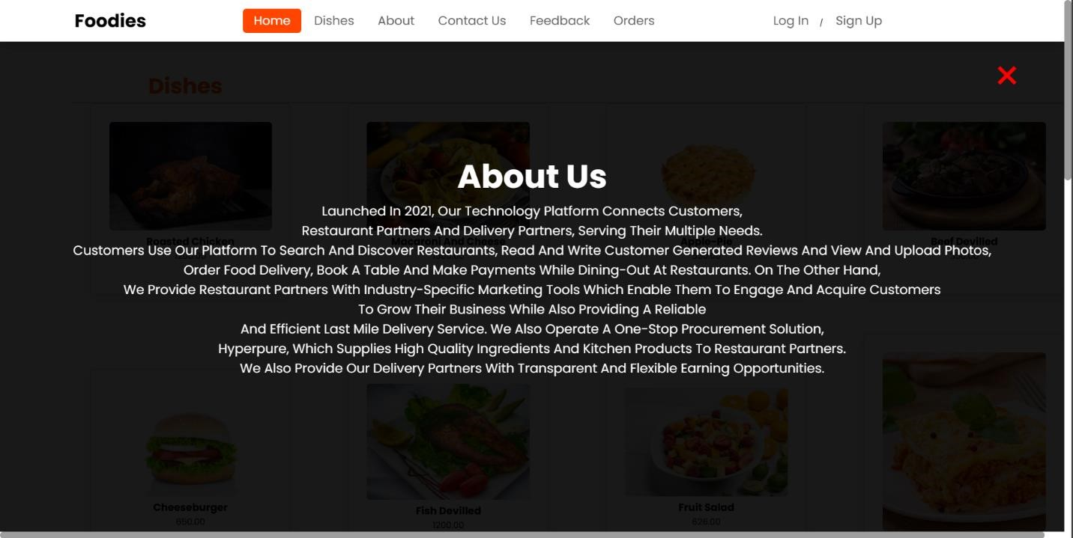

5.3.10 About Us

#### Dishes

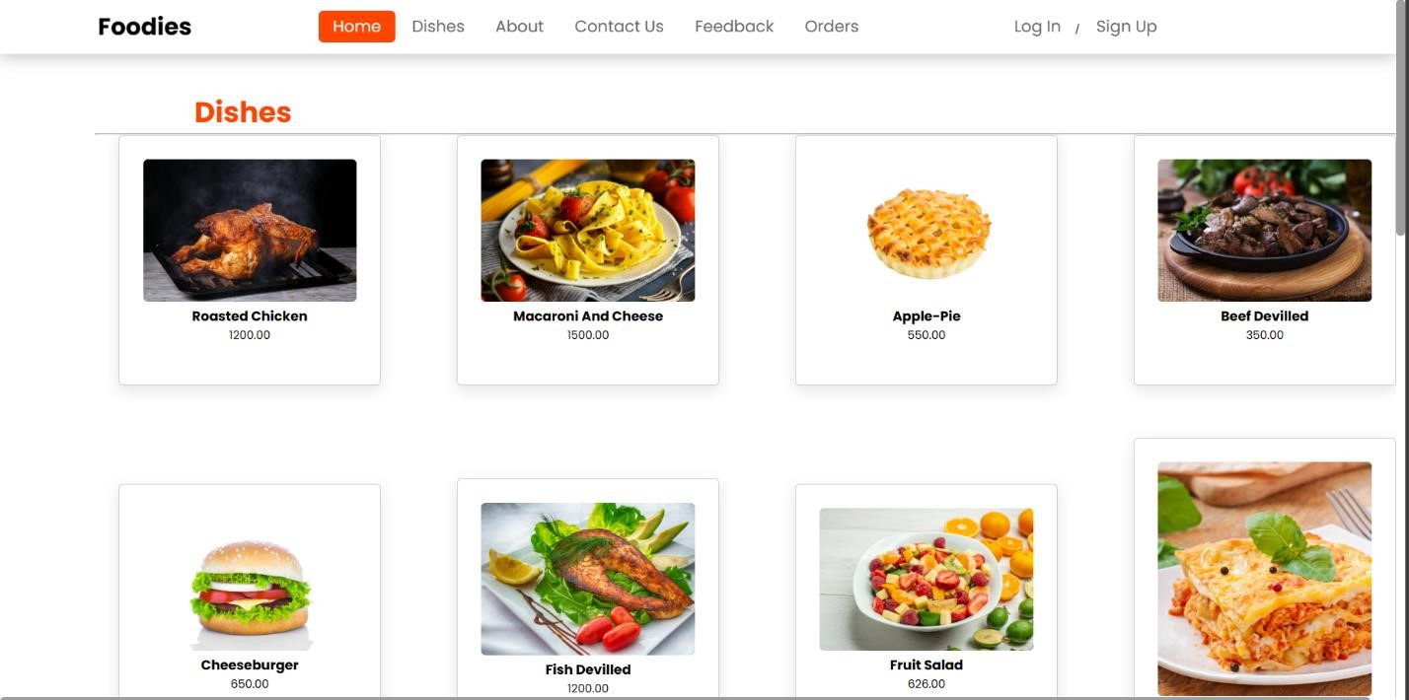

##### 5.3.11 Dishes 01

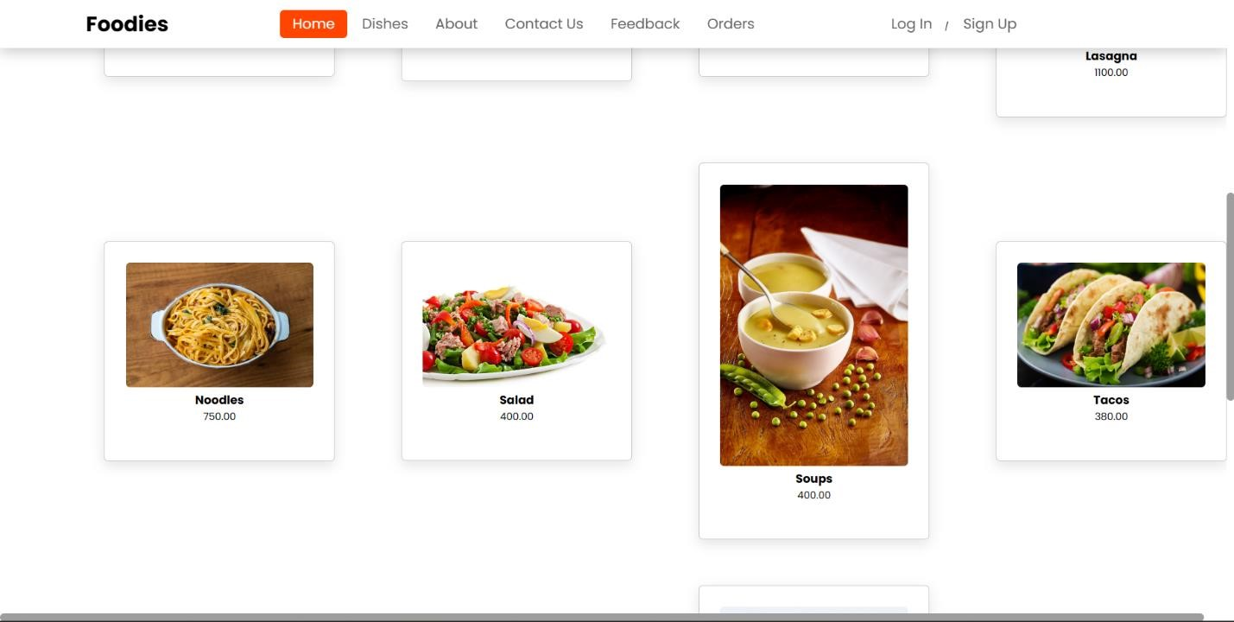

##### 5.3.12 Dishes 02

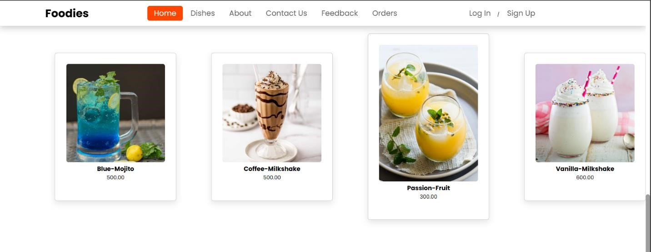

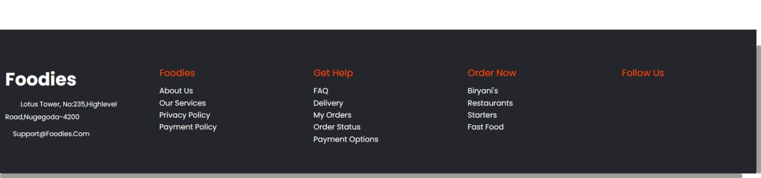



#### Contact Us

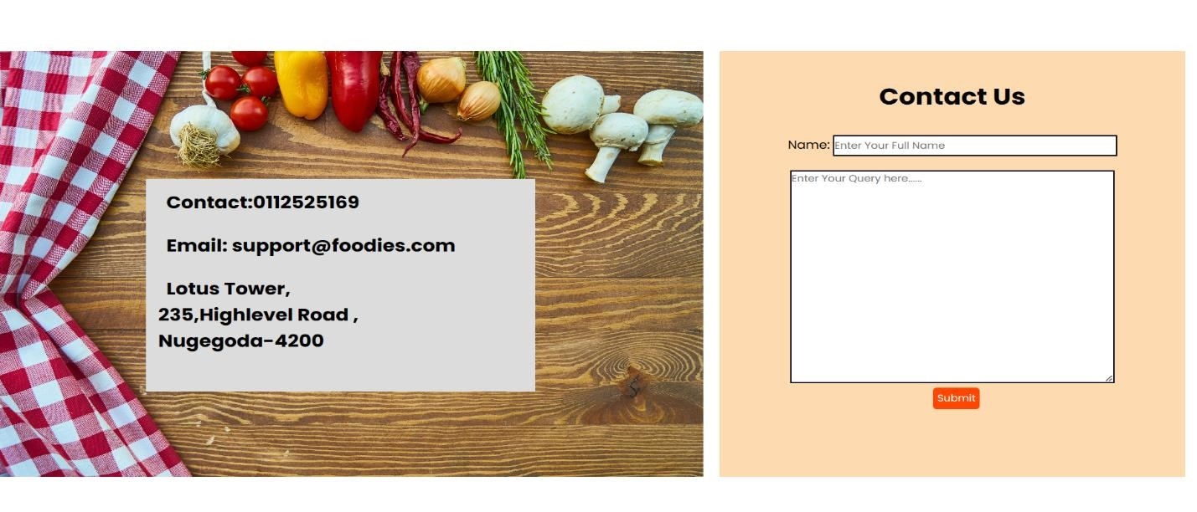

5.3.14 Contact Us

#### Add to cart

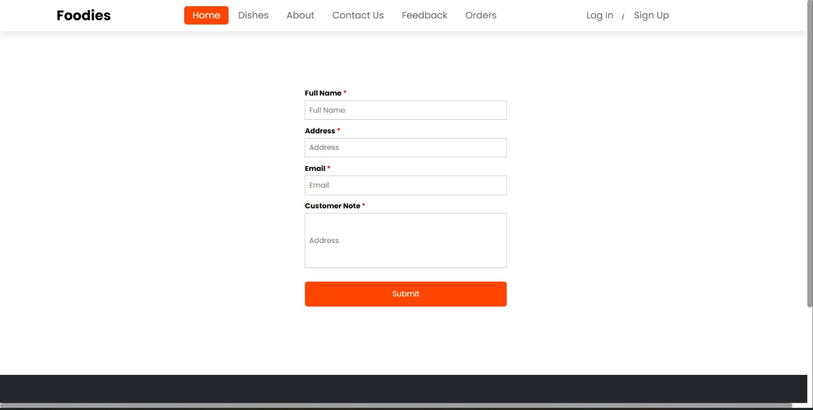

5.3.15 Add to cart

**6. Detailed Design**

## 6.1. Class diagram

**Sequence diagram for user registration**

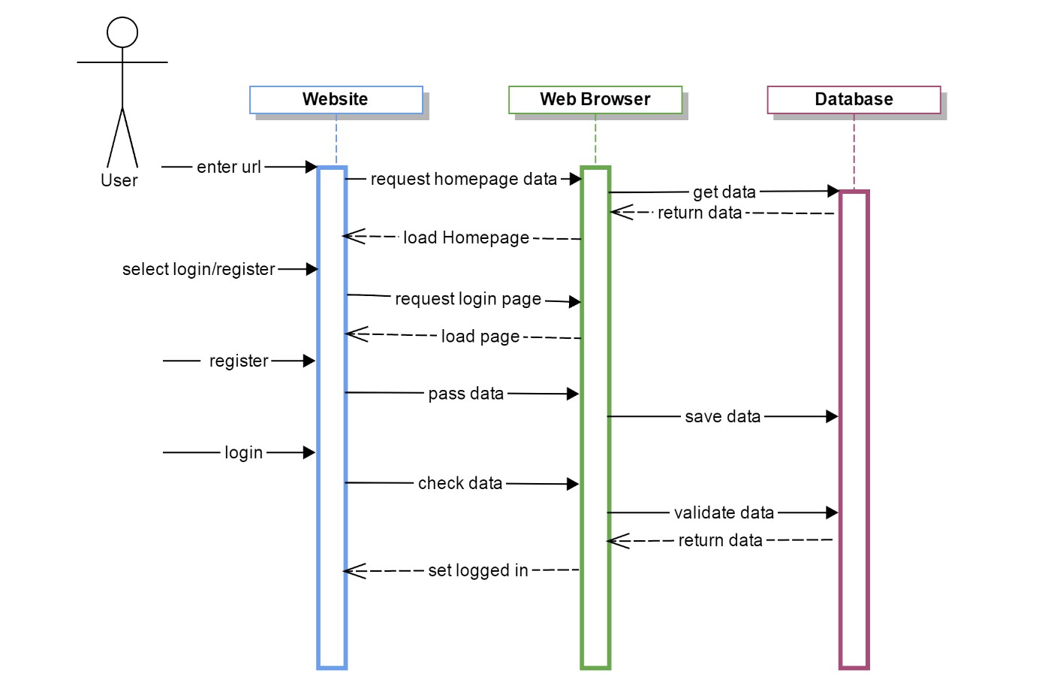

6.1.1 Sequence diagram 01

#### Sequence diagram for placing order

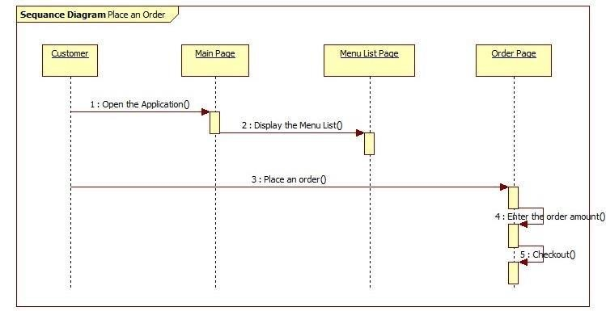

6.1.2 Sequence diagram 02

#### Sequence diagram for delivery

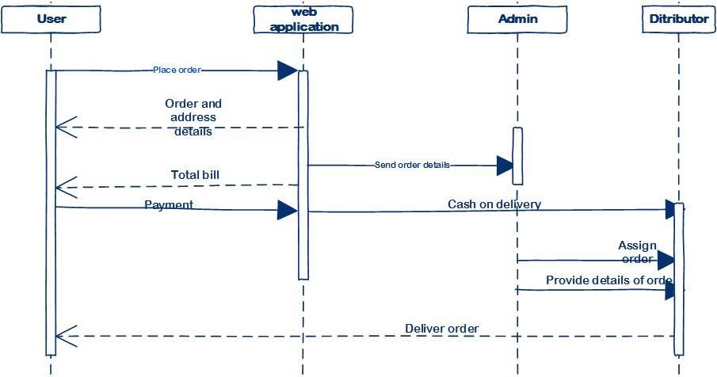

6.1.3 Sequence diagram 03

# Summary

An online food ordering system is a digital platform that allows customers to place food orders and pay for them online. The system typically consists of a website or mobile app that customers can use to browse menus, select items, customize their orders, and submit payment.

Once an order is placed, the system sends it to the restaurant or food vendor, who prepares the food and arranges for delivery or pickup. The system may also include features such as order tracking, delivery status updates, and customer reviews.

From the perspective of the restaurant or food vendor, an online food ordering system can streamline the order-taking process, reduce errors, and increase efficiency. It can also help businesses reach a wider audience by making their menus and offerings available online. The system may also include features like order tracking, delivery status updates, and customer reviews. This system can enhance the order-taking process, minimize errors, and improve business efficiency for restaurants and food vendors. Ultimately, an online food ordering system can provide a seamless and convenient way for customers to place orders and for businesses to manage orders and operations.

Overall, an online food ordering system can provide a convenient and efficient way for customers to order food and for businesses to manage their orders and operations.